**Steps are followed to make the project “Bike Rental Prediction”**

1. **Exploratory data analysis:**

* Load the dataset and the relevant libraries
* Perform data type conversion of the attributes
* Carry out the missing value analysis

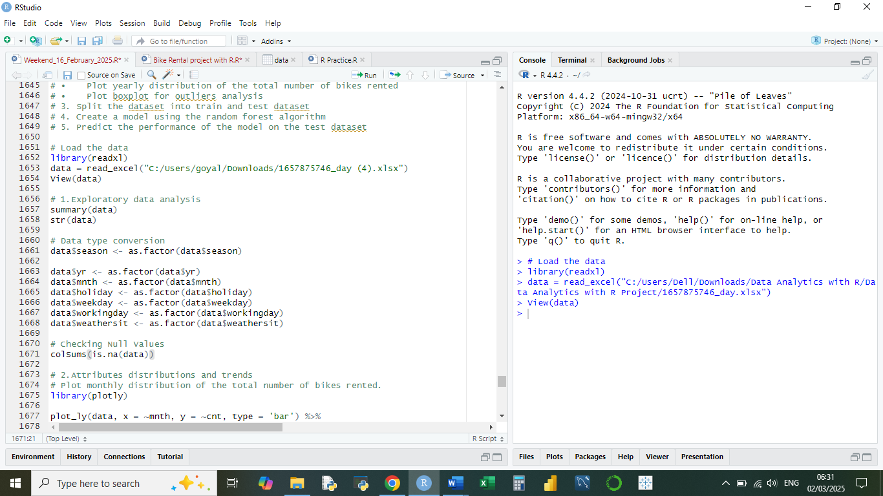

1. **Attributes distribution and trends**

* Plot monthly distribution of the total number of bikes rented
* Plot yearly distribution of the total number of bikes rented
* Plot boxplot for outliers' analysis

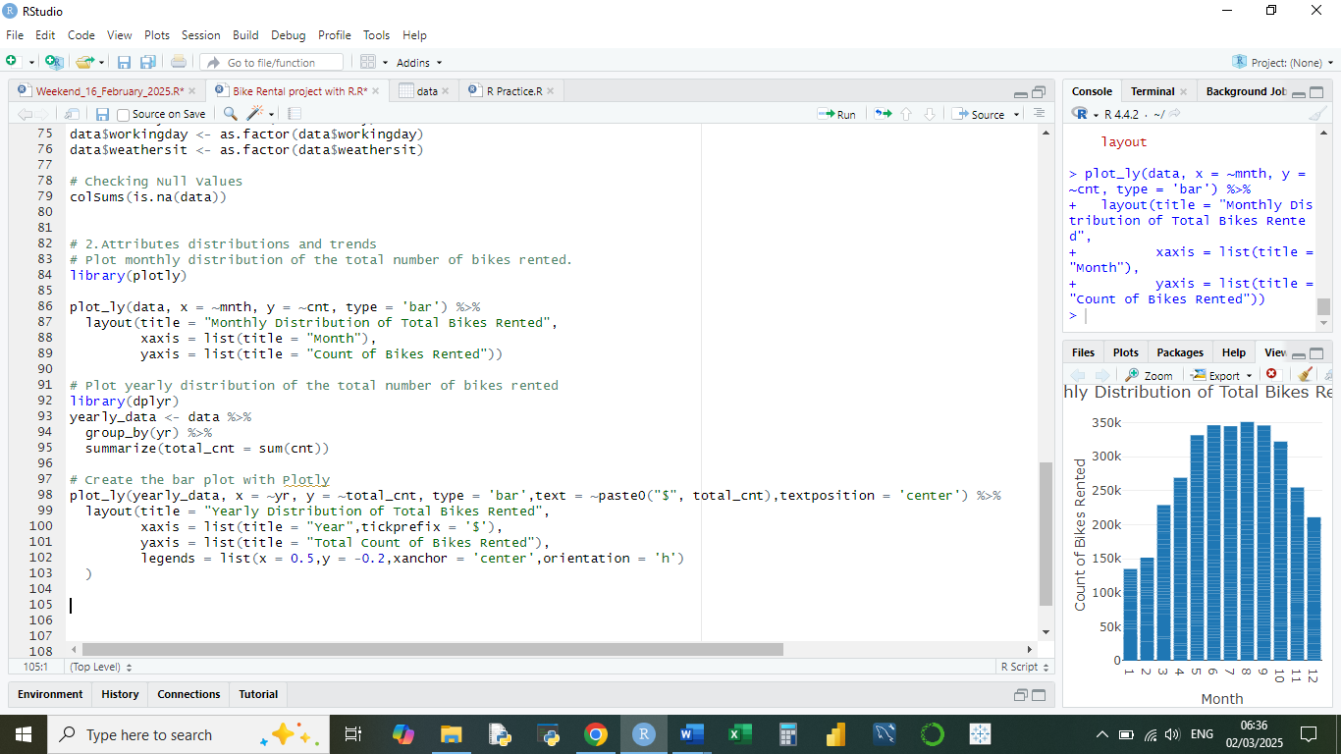

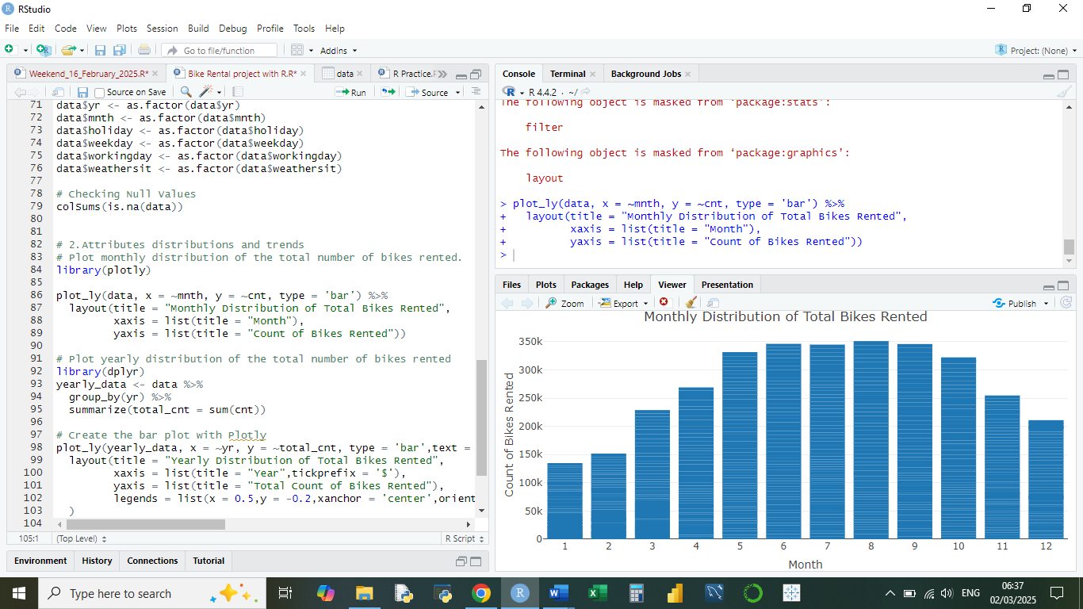

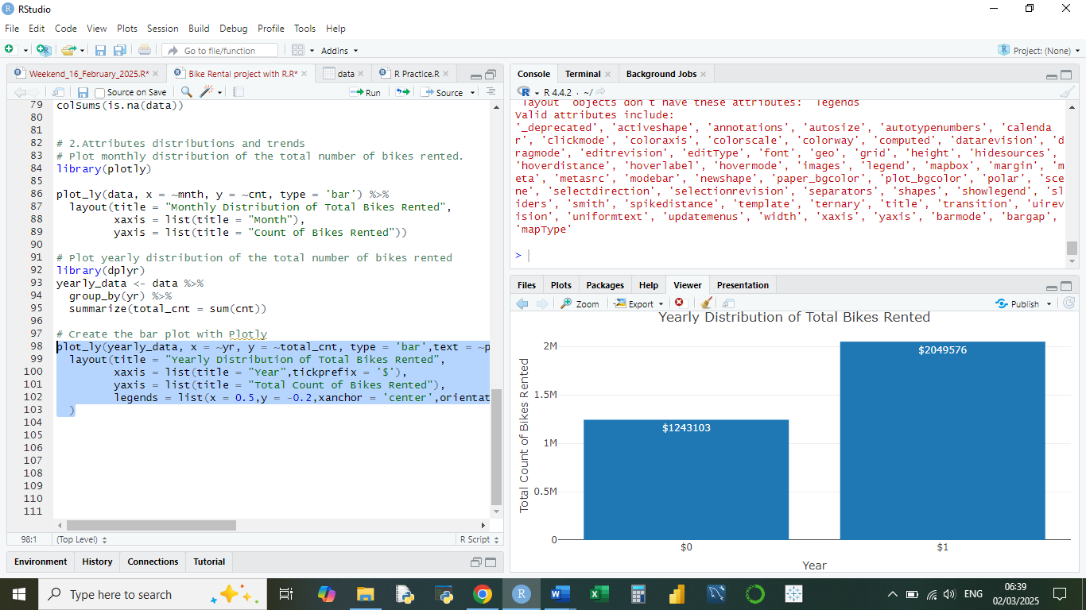

Box Plot for outliers' analysis

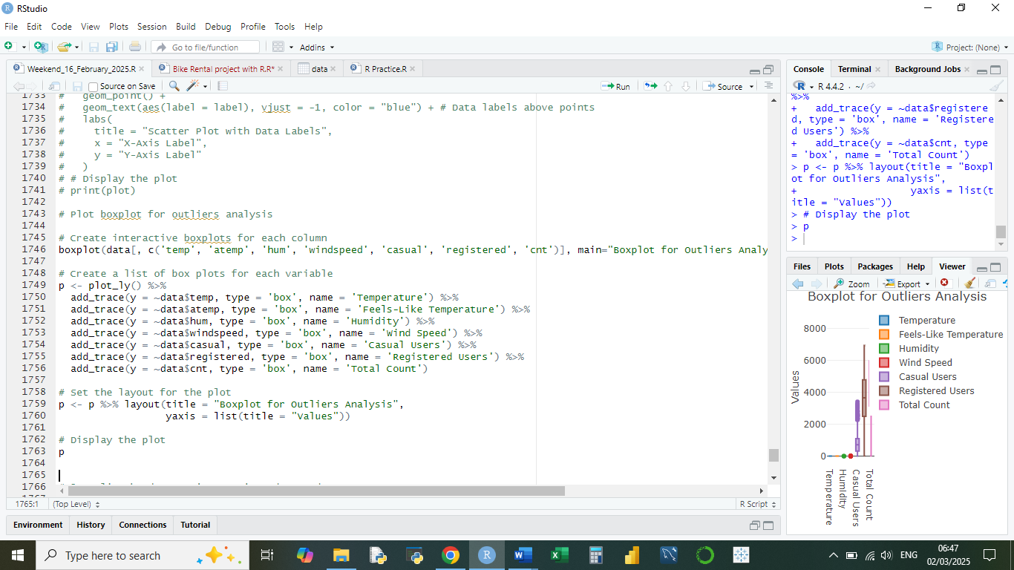

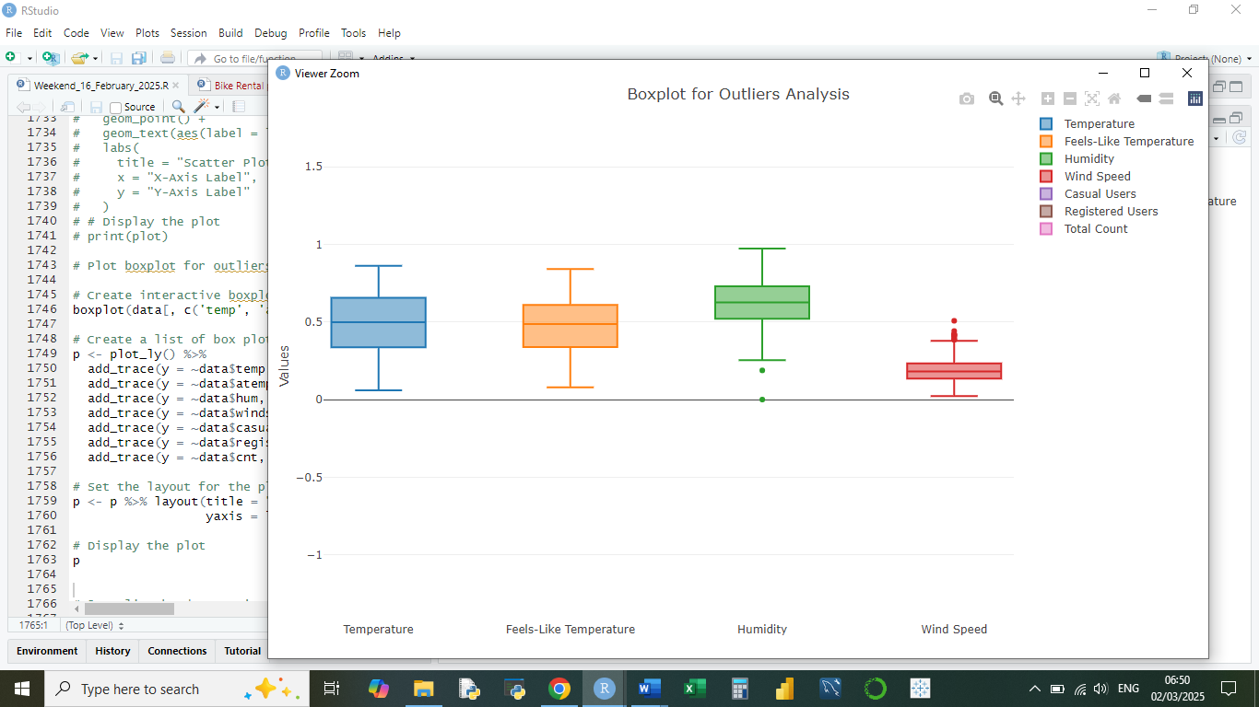

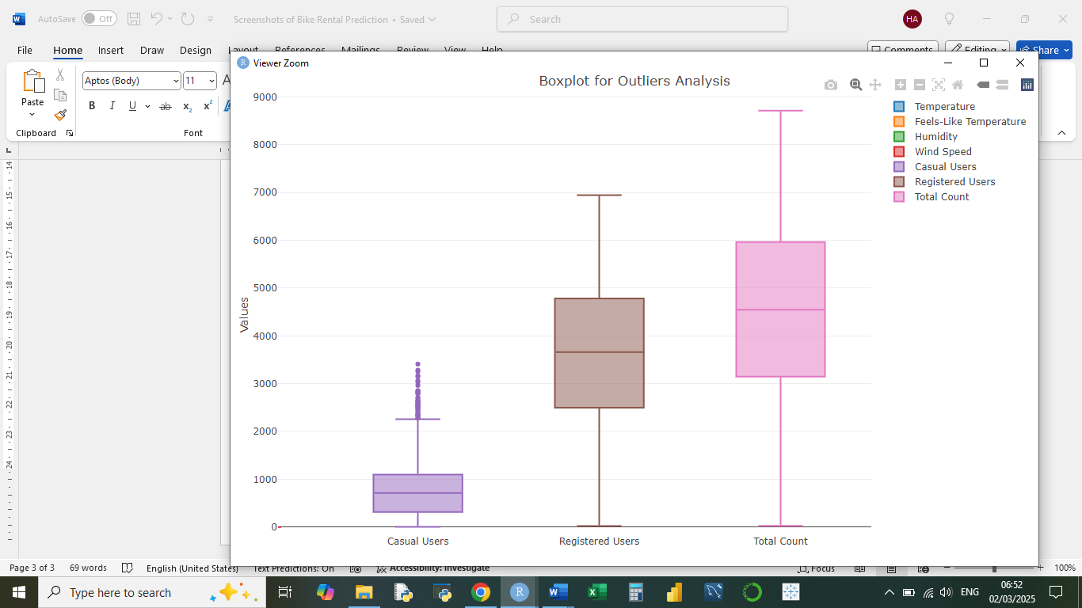

1. **Split the dataset into the train and test dataset**

1. **Create a model using the random forest algorithm**

1. **Predict the performance of the model on the test dataset**

